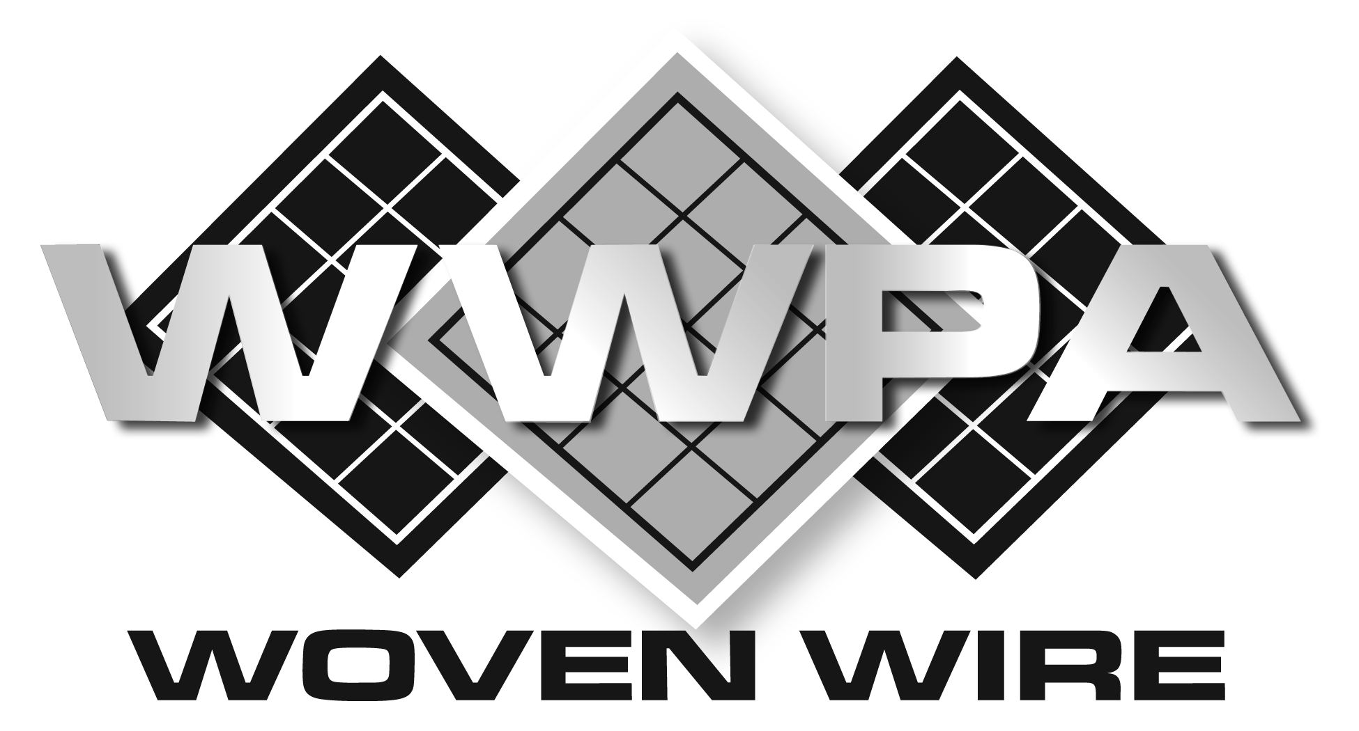

SECTION 10 22 13

HEAVY DUTY WIRE MESH PARTITIONS

** NOTE TO SPECIFIER ** heavy duty woven wire mesh partitions, wire mesh infill panels, window guards, and area guarding.
.
This section is based on the products manufactured by active members of the Woven Wire Products Association. For more information, please contact:

Woven Wire Products Association
P.O. Box 424
ATTN: Kimberly Adkins, Executive Secretary
Mason, Ohio 45040
Email: info@wovenwire.org
Web: www.wovenwire.org
The Woven Wire Products Association (WWPA) was established in 1942 as a professional association representing U.S. manufacturers of diamond woven wire mesh products. WWPA members emphasize high quality workmanship and ethical business standards, and produce woven wire products for institutional, industrial, and architectural applications.
With over 1,000 years of combined experience, WWPA member companies are the preeminent manufacturers of woven wire partitions, window guarding, and railing infill panels. Architects and general contractors have trusted the WWPA over the years to deliver high quality products, along with exact specifications to match the needs of their active projects.
.
- GENERAL
  - SUMMARY
** NOTE TO SPECIFIER ** Delete items below not required for project.
    - Heavy-Duty Wire Mesh Partitions
    - Wire Mesh Stairway Partitions and Enclosures
    - Temporary Holding Cells
    - Vertical Lift Enclosures
  - RELATED DOCUMENTS
** NOTE TO SPECIFIER ** Delete any sections below not relevant to this project; add others as required.
    - Drawings and general provisions of the Contract, including General and Supplementary Conditions and Division 01 Specification Sections, apply to this Section.
    - Section 03300 - Cast-In-Place Concrete: Restriction on location and penetration depth of fasteners.
  - SUBMITTALS
    - Submit under provisions of Section 01 30 00.
    - Product Data: Manufacturer's data sheets on each product to be used, including:
      - Detailed specification of construction and fabrication.
      - Manufacturer's installation instructions.
      - Preparation instructions and recommendations.
      - Storage and handling requirements and recommendations.
    - Shop Drawings: Indicate dimensions, description of materials and finishes, general construction, specific modifications, component connections, anchorage methods, hardware, and installation procedures, plus the following specific requirements.
      - Provide location template drawings for items supported or anchored to permanent construction.

** NOTE TO SPECIFIER ** Delete selection samples if colors have already been selected.
    - Selection Samples: For each finish product specified, two complete sets of color chips representing manufacturer's full range of available colors and patterns.
  - QUALITY ASSURANCE
    - Installer Qualifications
      - Construct areas designated by Architect.
      - Do not proceed with remaining work until workmanship, color, and sheen are approved by Architect.
      - Repair and correct mock-up area as required to produce acceptable work.
    - Design Requirements:
      - Design partition system to provide for movement of components without damage, undue stress on fasteners or other detrimental effects, when subject to design loads.
      - Design system to accommodate construction tolerances, deflection of building structural members, and clearances of intended openings.
    - Source Limitations: Obtain wire mesh items for single source from single manufacturer.
  - DELIVERY, STORAGE, AND HANDLING
    - Store products in manufacturer's unopened packaging until ready for installation.
** NOTE TO SPECIFIER ** Delete items below not required for project. Wrapping and packaging as detailed below may require additional costs.
      - Materials may ship uncrated per Manufacturer’s recommendation in order to maximize volume on common carrier and to reduce freight cost.
      - Materials to be crated or palletized with cardboard protectors on perimeters of panels and doors and strapped using nylon materials within crating. Crates are non-returnable and the responsibility of the customer for proper disposal.
      - Posts to be wrapped to provide protection during transit.
    - Store products in manufacturer’s unopened packaging until ready for installation.
    - Inventory wire mesh partition door hardware on receipt and provide secure lockup for wire mesh partition door hardware delivered to Project site.
    - Keys: Submit keys for door locks to Owner at Substantial Completion of the project. Special lock requests (e.g., master lock or dual cylinder systems) must be specified at time of quotation.
  - PROJECT CONDITIONS
    - Field Measurements: Customer to verify actual dimensions of construction contiguous with wire mesh units by field measurement before fabrication.
    - Maintain environmental conditions (temperature, humidity, and ventilation) within limits recommended by manufacturer for optimum results. Do not install products under environmental conditions outside manufacturer's absolute limits.
- PRODUCTS
  - MANUFACTURERS
    - Acceptable Manufacturers: Active members, in good standing, with the Woven Wire Products Association (WWPA), www.wovenwire.org:
** NOTE TO SPECIFIER ** We suggest you verify the member is still in good standing to be considered for solicitation by reviewing our active member list at www.wovenwire.org
      - Apex Iron Works
      - G-S Company, The
      - Indiana Wire Products
      - Kenco Wire & Iron Products, Inc.
      - Miller Wire Works, Inc.
      - Newark Wire Works, Inc.
      - Robert J. Donaldson Co., Inc.
      - SpaceGuard Products, Inc.
      - Standard Wire & Steel Works
      - Wire & Iron Products (WIPCO), a Division of Jesco Industries, Inc.
    - Substitutions: Not permitted if only considering materials certified by the Woven Wire Products Association
  - MATERIALS
    - Steel Wire: ASTM A 510 (ASTM A 510M).
    - Steel Plates, Channels, Angles, and Bars: ASTM A 36/A 36M.
    - Cold-Rolled Steel Sheet: ASTM A 1008/A 1008M, Commercial Steel (CS), Type B.
    - Square Steel Tubing: ASTM A 500, cold-formed structural steel tubing.
    - Panel-to-Panel Fasteners: Manufacturer’s standard steel bolts, nuts, and washers.
    - Postinstalled Expansion Anchors: With capability to sustain, without failure, load imposed within factors of safety indicated, as determined by testing per ASTM E 488, conducted by a qualified independent testing agency.
      - Carbon steel: Zinc plated to comply with ASTM B 633, Class Fe/Zn 5 (0.005 mm) for Class SC 1 service condition (mild)
      - For Postinstalled Anchors in Concrete: Capability to sustain, without failure, a load equal to four times the loads imposed.
  - PRODUCT
    - Mesh: No. 6 gauge, steel wire triple crimped and woven into 2 inch diamond or a 2 inch square mesh pattern.
    - Horizontal Frames: 1-1/2 inch by 3/4 inch - 11 gauge or thicker steel channel.
    - Vertical Frames: 1-1/2 inch by 3/4 inch - 11 gauge or thicker roll formed "C" type steel channels. Series of slotted holes for securing to adjacent panels and post.
    - Horizontal Reinforcement Members: Two 1 inch by 1/2 inch or greater - 11 gauge or thicker steel channel toe riveted or bolted together through mesh and welded to vertical frames.
    - Panels: Single panels are made up to 60 inches wide and 144 inches high. Consisting of the above horizontal and vertical members mortised and tenoned at corners with diamond mesh securely attached to frames. Lower horizontal member located a maximum 3-3/4 inch from bottom of panel to create maintenance sweep space. Center reinforcement bars attached, as noted.
** NOTE TO SPECIFIER ** Delete sheet metal base unless lower level sheet metal wainscot is absolutely required for security
      - Sheet Metal Base: 16 gauge sheet metal Wainscot to be attached to panel below the horizontal reinforcement bar

Panels: Single panels are made in any width up to 60 inches and heights up to 144 inches. Consisting of the above horizontal and vertical members mortised and tenoned at corners with diamond mesh securely attached to frames. Lower horizontal member is located no more than 3-3/4 inch from bottom of panel to create maintenance sweep space. Horizontal reinforcement bars attached, as noted. ** NOTE TO SPECIFIER ** Delete door type if not required.
    - Hinge Doors: Constructed of the same materials as panels, with 1-1/2 inch by 3/4 inch flat steel bar cover on sides. Complete with all necessary mounting and locking hardware to install and operate.
      - Hinges: Three 3 inch by 3 inch or greater butt hinges
** NOTE TO SPECIFIER ** Delete lock type not required.
      - Padlock Arrangement: Lug(s) to be welded, through bolted, or riveted securely to system.
Cylinder Lock: Mortise type with keyed different cylinder operated by key outside and recessed turn knob inside. Panels: Single panels are made in any width up to 60 inches and heights up to 144 inches. Consisting of the above horizontal and vertical members mortised and tenoned at corners with diamond mesh securely attached to frames. Lower horizontal member is located no more than 3-3/4 inch from bottom of panel to create maintenance sweep space. Horizontal reinforcement bars attached, as noted. ** NOTE TO SPECIFIER ** Delete door type if not required.
    - Slide Doors: Constructed of the same or greater materials as panels, with 1-1/2 inch by 3/4 inch flat steel bar cover on sides. Complete with all necessary mounting and locking hardware to install and operate.
      - Hardware: Two 2-wheel or 4-wheel rolling trolleys per every 5 feet of door width, in an enclosed box track. Door guide shall not allow door to be lifted or pulled from track when locked.
** NOTE TO SPECIFIER ** Delete lock type not required.
      - Padlock Arrangement: Lug(s) to be welded, through bolted, or riveted securely to system.
      - Cylinder Lock: Mortise type with keyed different cylinder operated by key outside and recessed turn knob inside.
** NOTE TO SPECIFIER ** Delete service window if not required.
    - Service Window (slide-up type): 24 inch wide by 21.5 inch high opening with 24 inch wide by 12 inch deep - 12 gauge shelf centered in opening and secured to base with three 1/4 inch by 1 inch flat head screws. Window panel constructed of the same materials as standard panels.
    - Corner post (for 90 degree corner): A minimum 1-1/2 inch by 1-1/2 inch by 1/8 inch steel angle or square tube.
    - Vertical Stiffeners: For partitions greater than 144 inches in height:
      - Minimum 1/4 inch by 2 inch flat steel required from 12 feet to 16 feet in height
      - Minimum 5/16 inch by 3 inch flat steel required from 16 feet to 24 feet in height
      - 3 inch steel channel welded to base plate required when height exceeds 24 feet.
    - Line Post: Minimum 3 inch steel channel welded to base plate. Recommended every 10 to 20 feet on center to adequately stiffen long partition runs.
    - Top Capping Channel/Rail: When ceilings are not present, steel channel to be through bolted to or u-bolted around top horizontal frame member per the manufacturers recommended spacing. Channels should be cut to length to cover above panel-to-panel intersections whenever possible.
    - Floor Sockets: Die Cast base shoes to be used whenever a post is not present on panel-to-panel connections at the floor.
** NOTE TO SPECIFIER ** Delete Lines M through P if ceilings not required.
    - Ceiling Panels: Fabricated from same mesh, framing and reinforcement bars as panels above; except that horizontal bars are on each end eliminating maintenance sweep space in wall panels.
    - Ceiling Perimeter Angle: 1-1/2 inch by 1-1/2 inch by 14 gauge galvanized angle; punched for bolting to top of wire mesh wall panels and to sides of wire mesh ceiling panels. Attach to existing walls creating a ledge to support ceiling at an existing wall.
    - Ceiling Intermediate Beam Support: 2 inch by 4 inch by 14 gauge steel tube for use in spans exceeding 12 feet in any two directions.
    - Ceiling Intermediate Beam Support Post: 2 inch by 2 inch - 14 gauge steel tube welded to bottom and top base plates to support the beams. Ceiling to rest on, not attach to, support post, if required.
    - Finish:
** NOTE TO SPECIFIER ** Delete all except the required finish.
      - Powder coated in manufacturer’s standard gray or black.
      - Powder coated in color as selected by Architect from manufacturer’s standard color chart.
      - Sprayed enamel in manufacturer’s standard gray or black.
      - Sprayed enamel in color as selected by Architect from manufacturer’s standard color chart.
      - Hot-Dipped Galvanized

  - FABRICATION
    - Fabricate assemblies of framed sections; to sizes and profiles required; with framing members fitted, reinforced and braced to suit design requirements.
    - Fit and assemble in largest practical sections for delivery to Project Site, ready for installation.
    - Fabricate items with joints tightly fitted and secured.
    - Grind exposed welds smooth and flush with adjacent finish surface. Ease exposed edges to small uniform radius.
    - Make exposed joints flush and hairline.
    - Provide components required for anchorage. Fabricate anchorage and related components of same material and finish as framing members.
  - FINISH
    - Clean surfaces of rust, scale, grease, and foreign matter before finishing. Clean material using a two to three stage wash system immediately prior to finishing.
    - Prefinished Surfaces: Material to be prime coated if required prior to finishing.

- EXECUTION
  - EXAMINATION
    - Verification of Conditions: Examine areas and conditions under which Work is to be performed and identify conditions detrimental to proper or timely completion.
      - Do not proceed until unsatisfactory conditions have been corrected.
  - INSTALLATION
    - Comply with manufacturer's recommendations.
    - Install partitions and gates plumb and level, accurately fitted, properly aligned, securely fastened, and free from distortion or detects.
    - Install field bracing as necessary (not furnished by mesh partition manufacturer) to provide rigid, secure installation.
  - TOLERANCES
    - Maximum Variation from Plumb or Level: 1/4 inch (6 mm) in total partition height.
    - Maximum Misalignment from True Position: 1/4 inch (6 mm).
  - ADJUSTING
    - Adjust moving components for smooth operation without binding.
    - Adjust locks to provide smooth and secure operation.
  - PROTECTION
    - Protect installed products until completion of project.
    - Touch-up, repair or replace damaged products before Substantial Completion.

END OF SECTION

